**Creating New SOAP Project:**

* Go to File and Click on new SOAP Project.

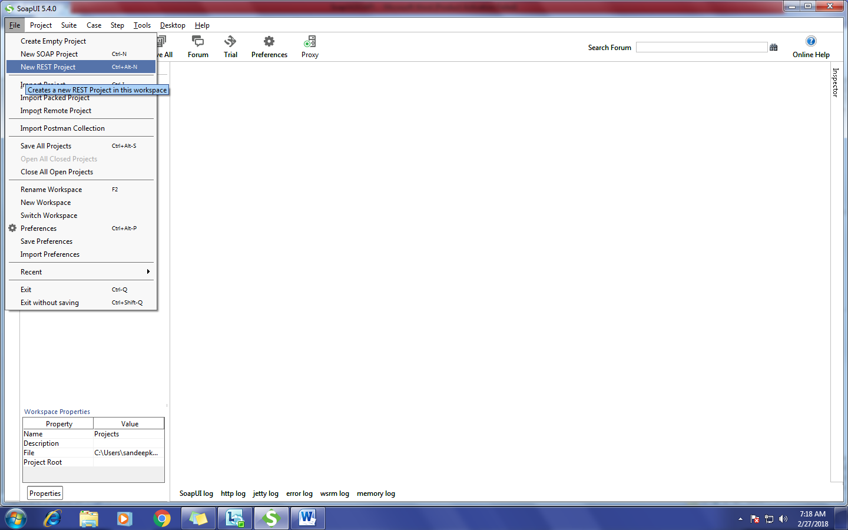

* Write the Project name and Browse or copy the WSDL file.
* Click on OK Button.

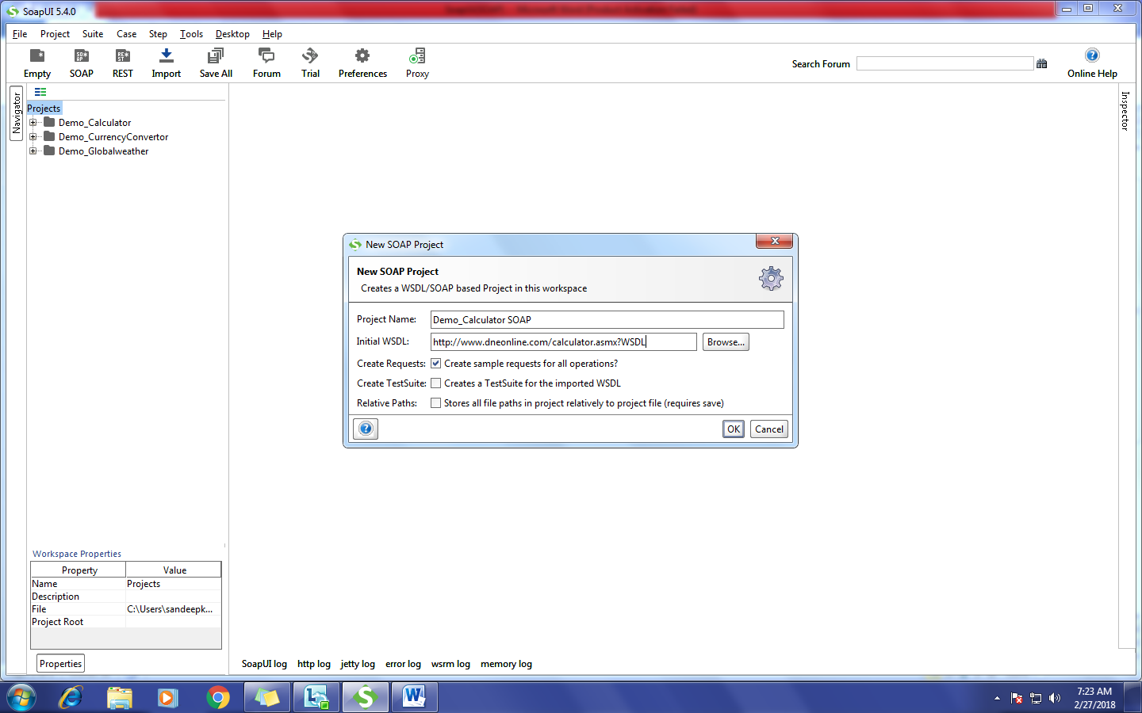

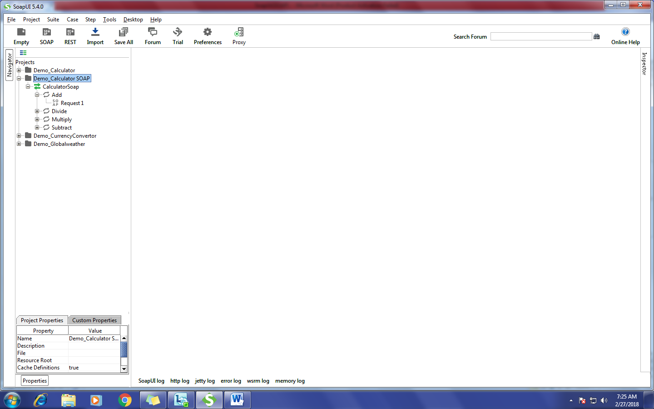

**To Verify the Response for Addition:**

* Double Click on Add Request.
* Enter two values in the place of ‘?’.
* Click on Run and verify the Response.

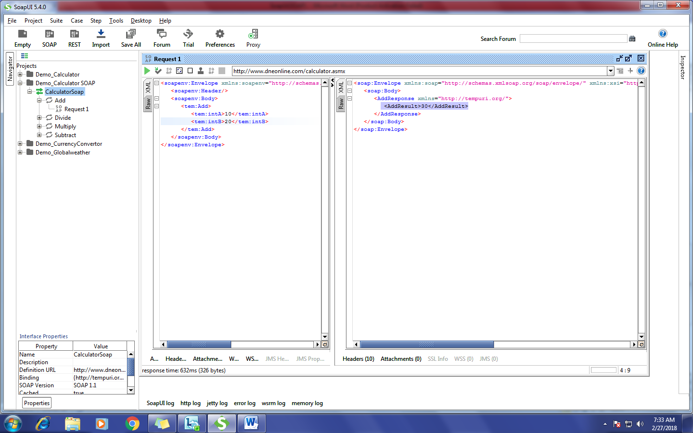

**Create this Request as a Test Case:**

* Click on Tick mark in the header.
* Write the Test Suit Name.
* Click on OK Button.

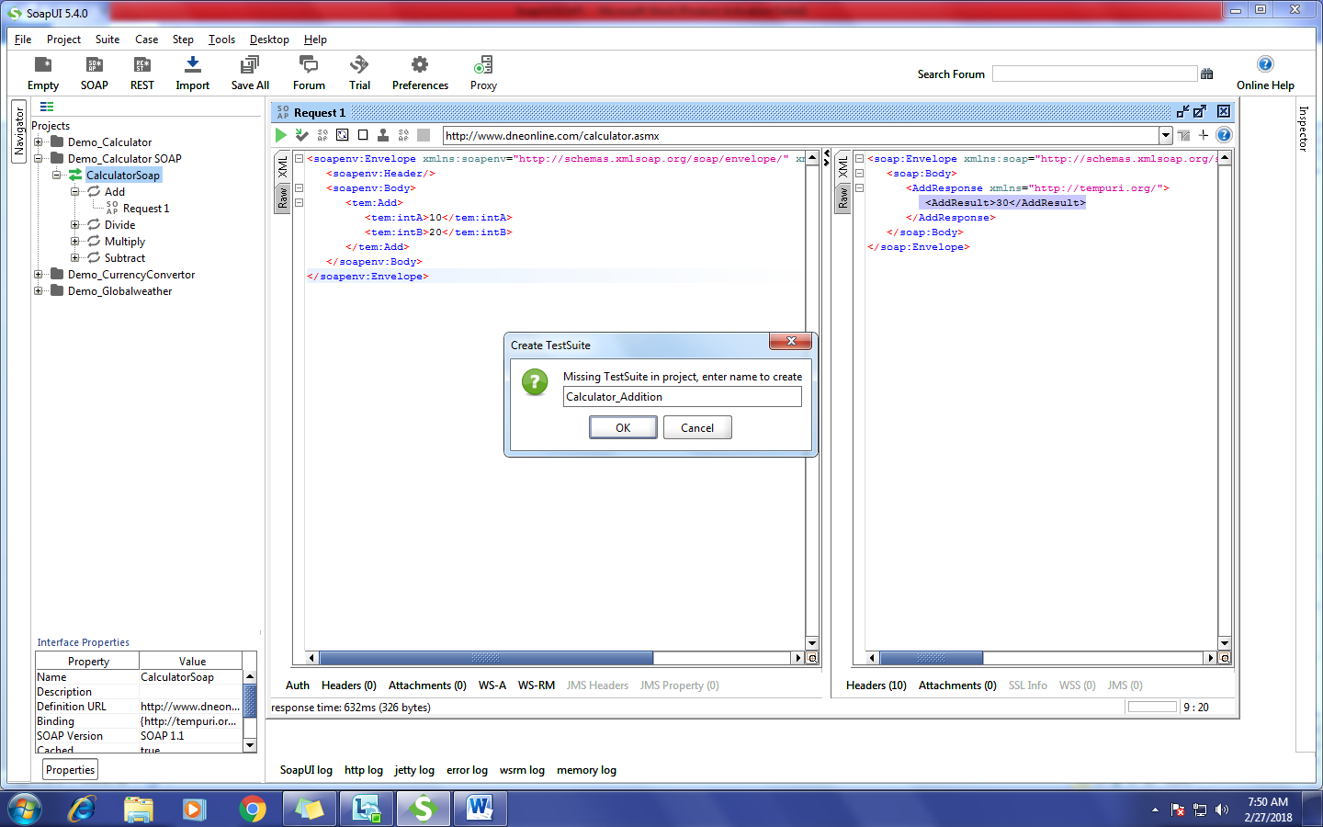

* Write the TestCase Name.
* Click on OK Button.

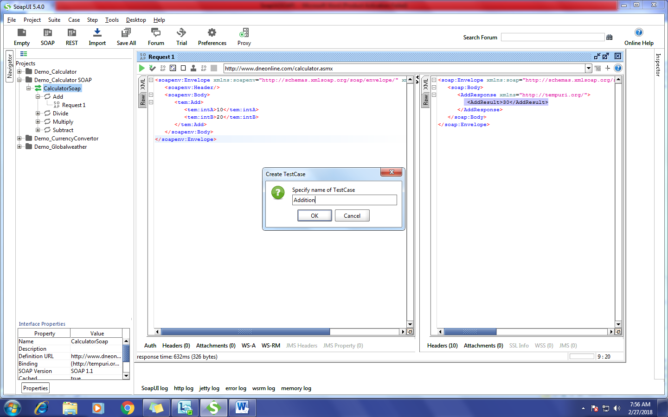

* Write the Request name and Click on Ok button.

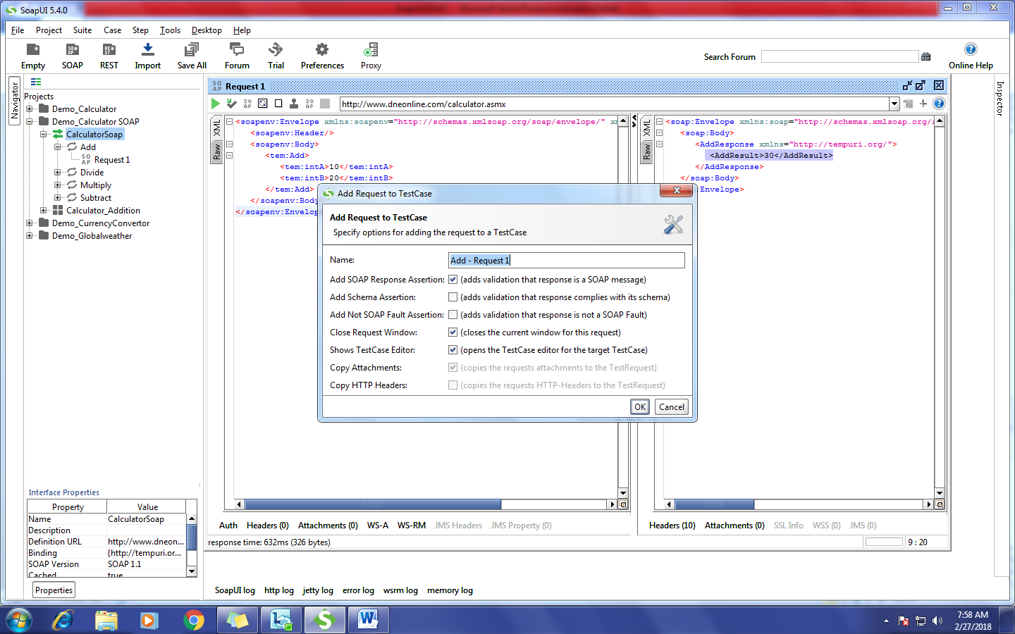

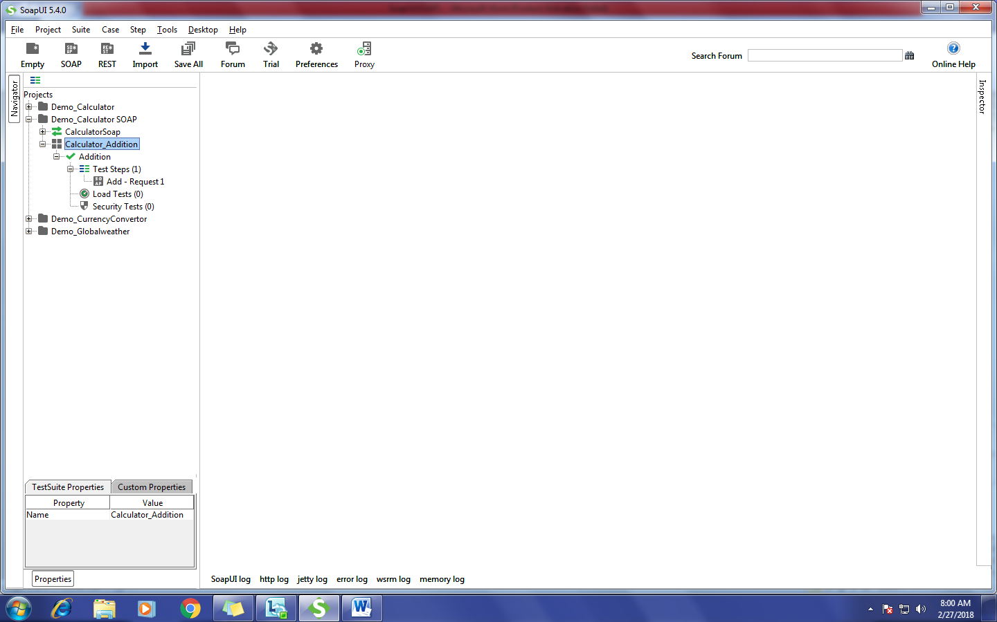

**Adding the Assertions in the Current Step:**

* Double Click on test case Request.
* Click on Assertions.

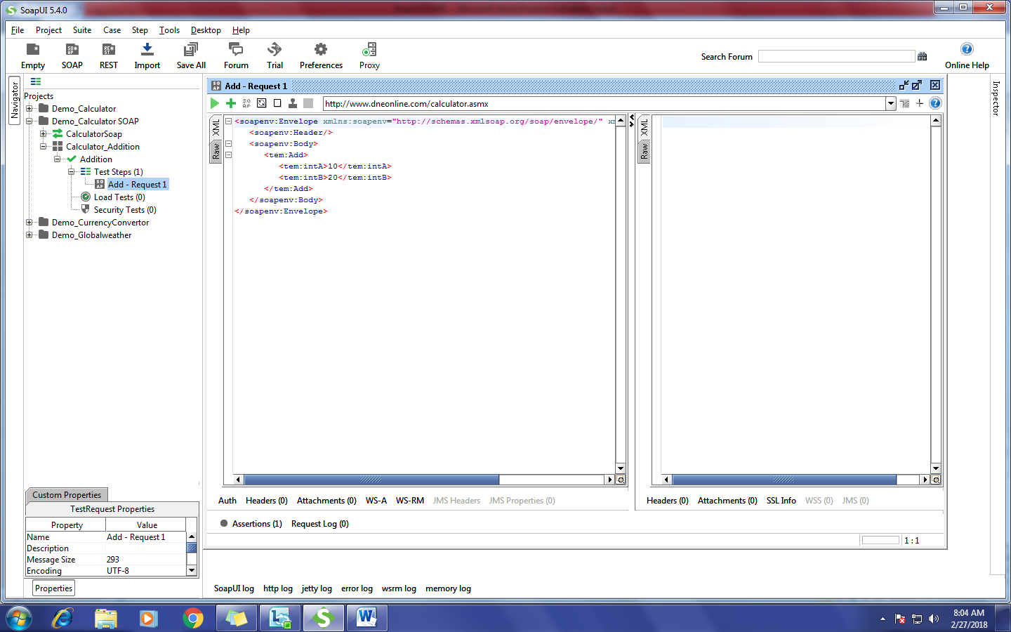

* Click on ‘**+’** icon and Add the assertions what you required.

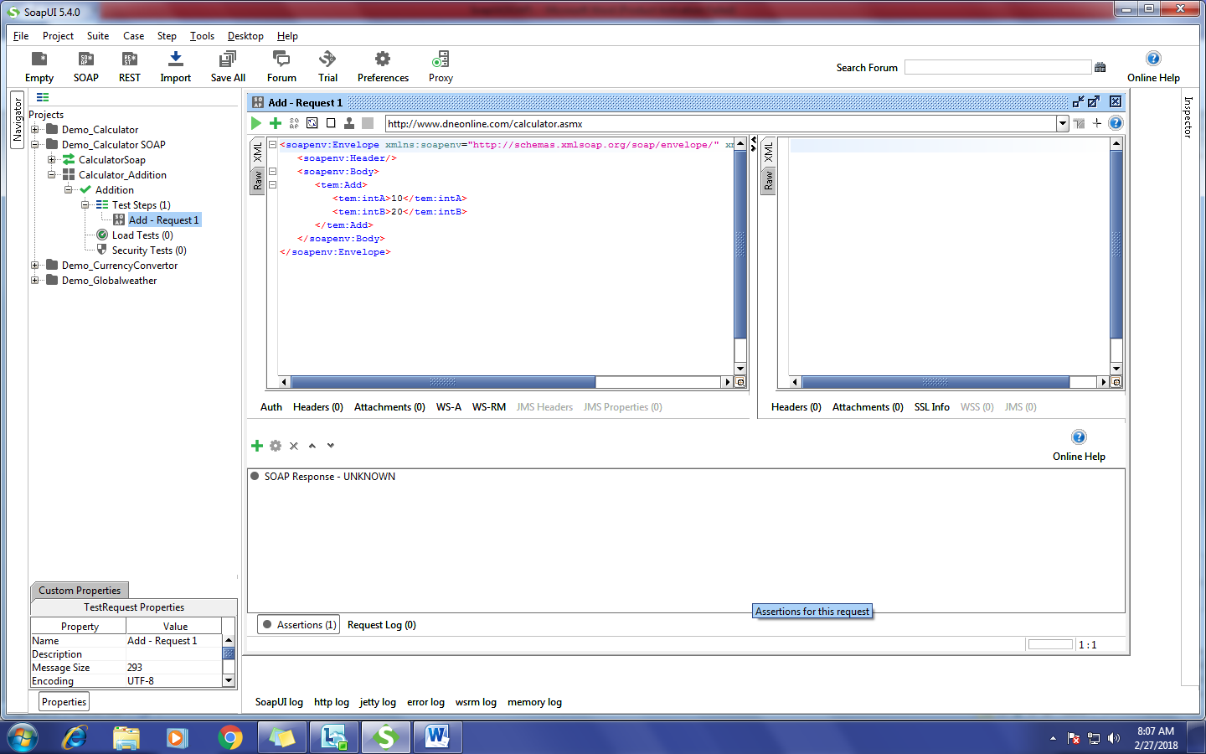

**Adding Property Content Assertions:**

* Contains
* Not Contains
* XPath Match

**Contains:**

* Click on ‘**+’** icon.
* Go to Property Content.
* Select the ‘Contains’.
* Click on Add Button.

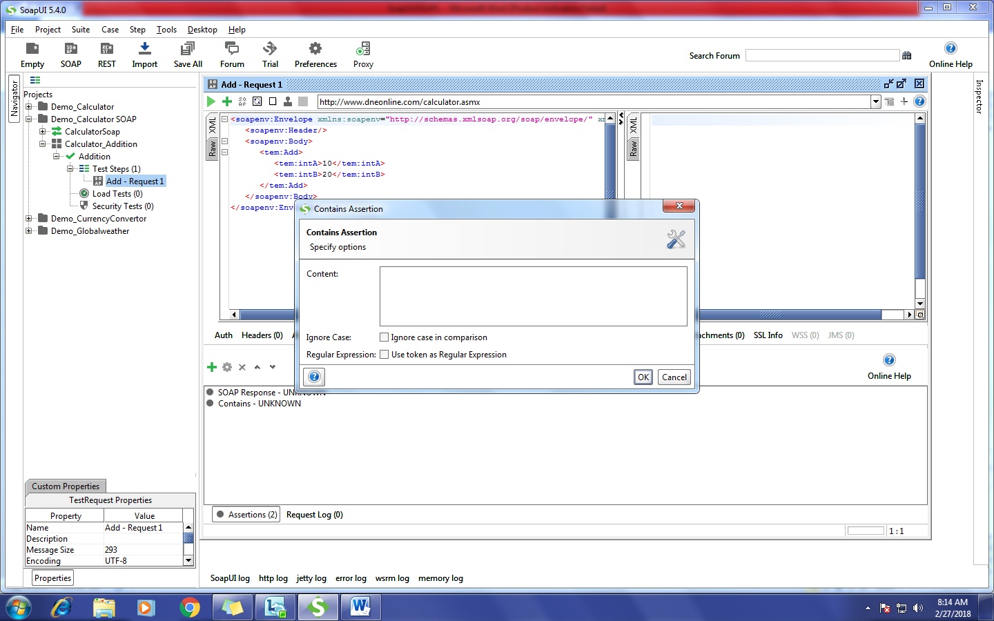

* Write the content in the text box.
* Click on Ok Button.

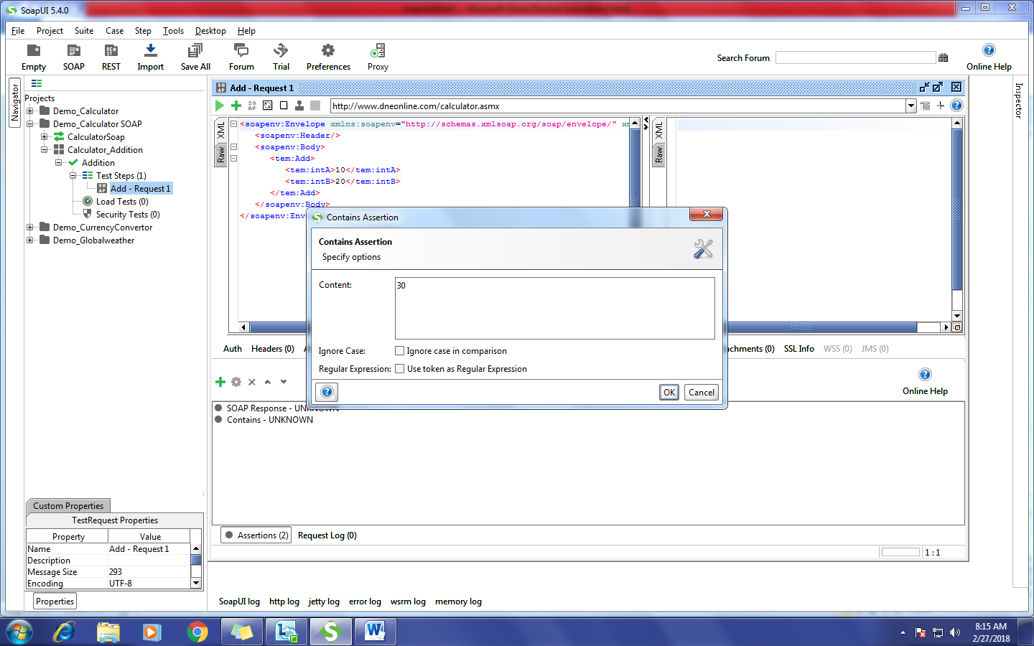

**Not Contains:**

* Click on ‘**+’** icon.
* Go to Property Content.
* Select the ‘Not Contains’.
* Click on Add Button.

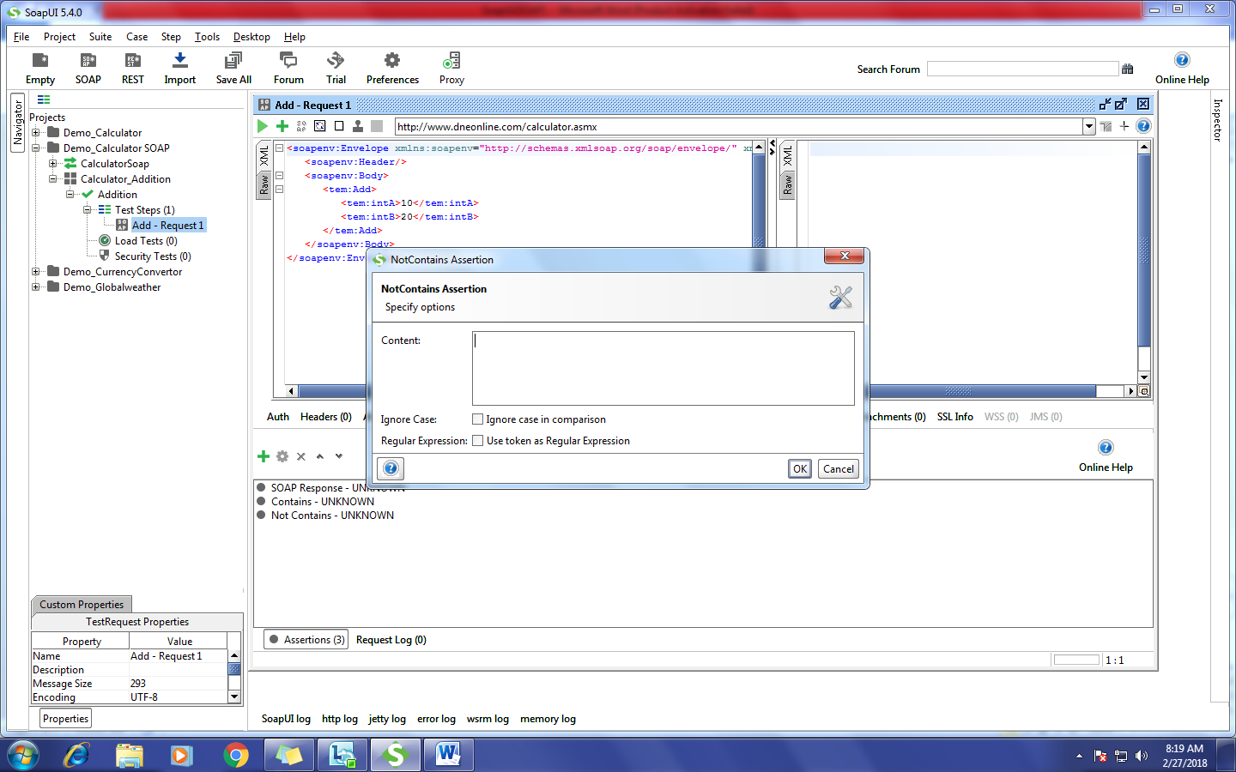

* Write the content in the text box (write any non-existing content).
* Click on Ok Button.

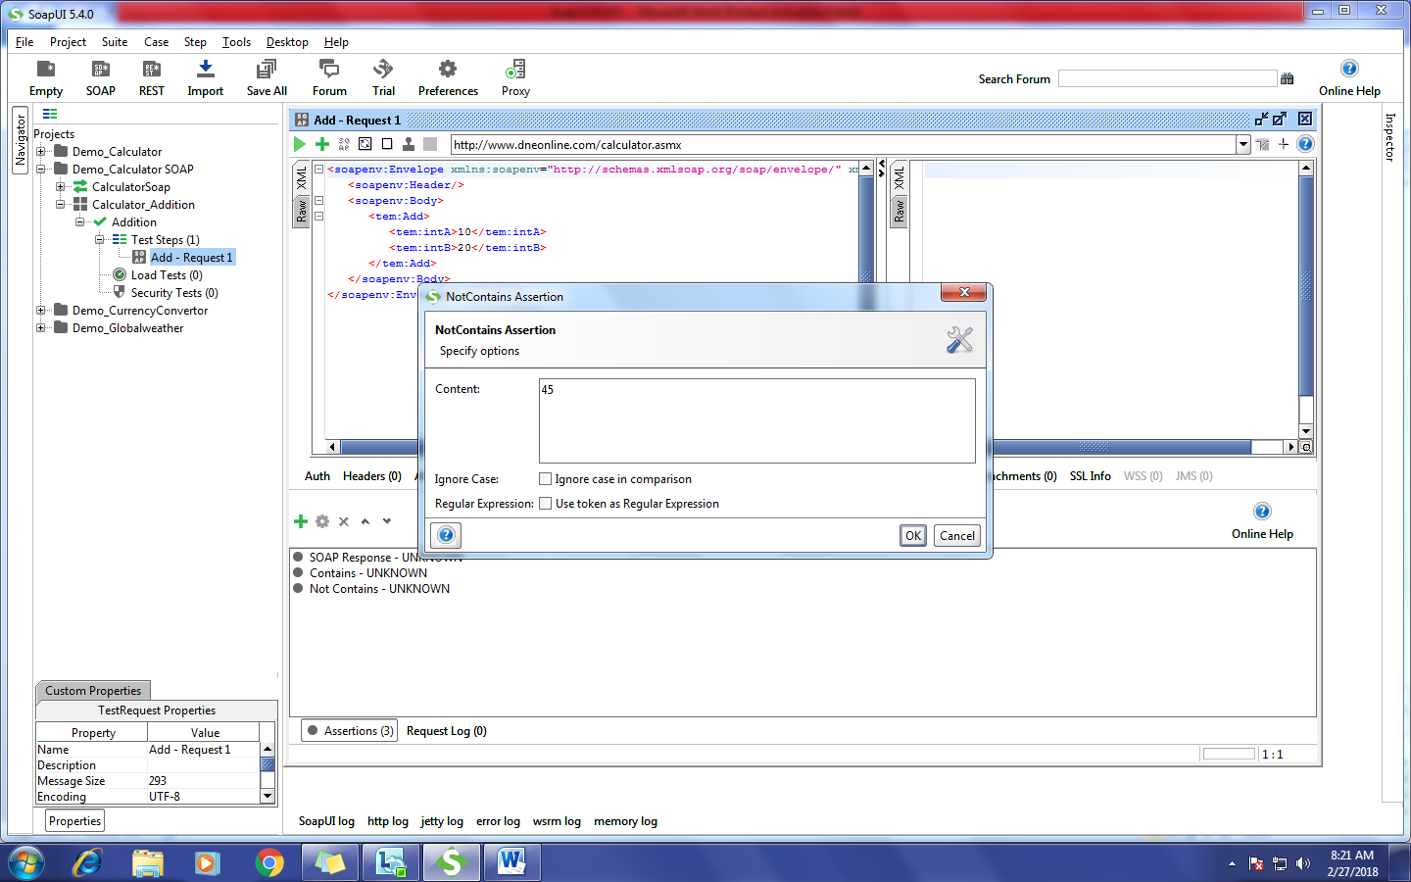

**XPath Match:**

* Click on ‘**+’** icon.
* Go to Property Content.
* Select the ‘XPath’.
* Click on Add Button.

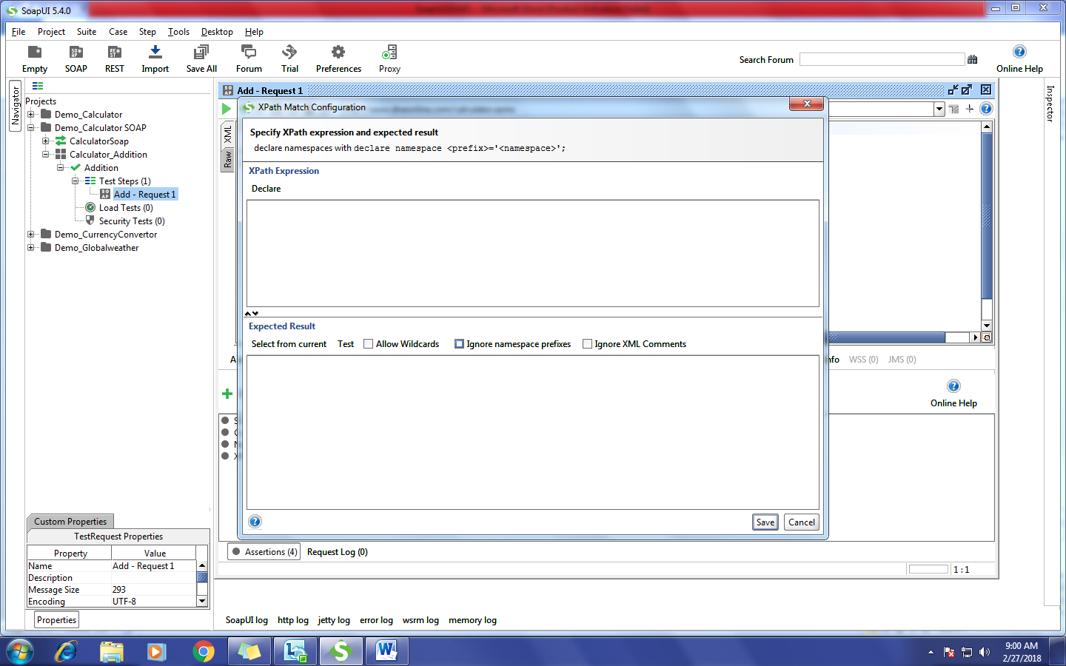

* Write the XPath and click on Save.

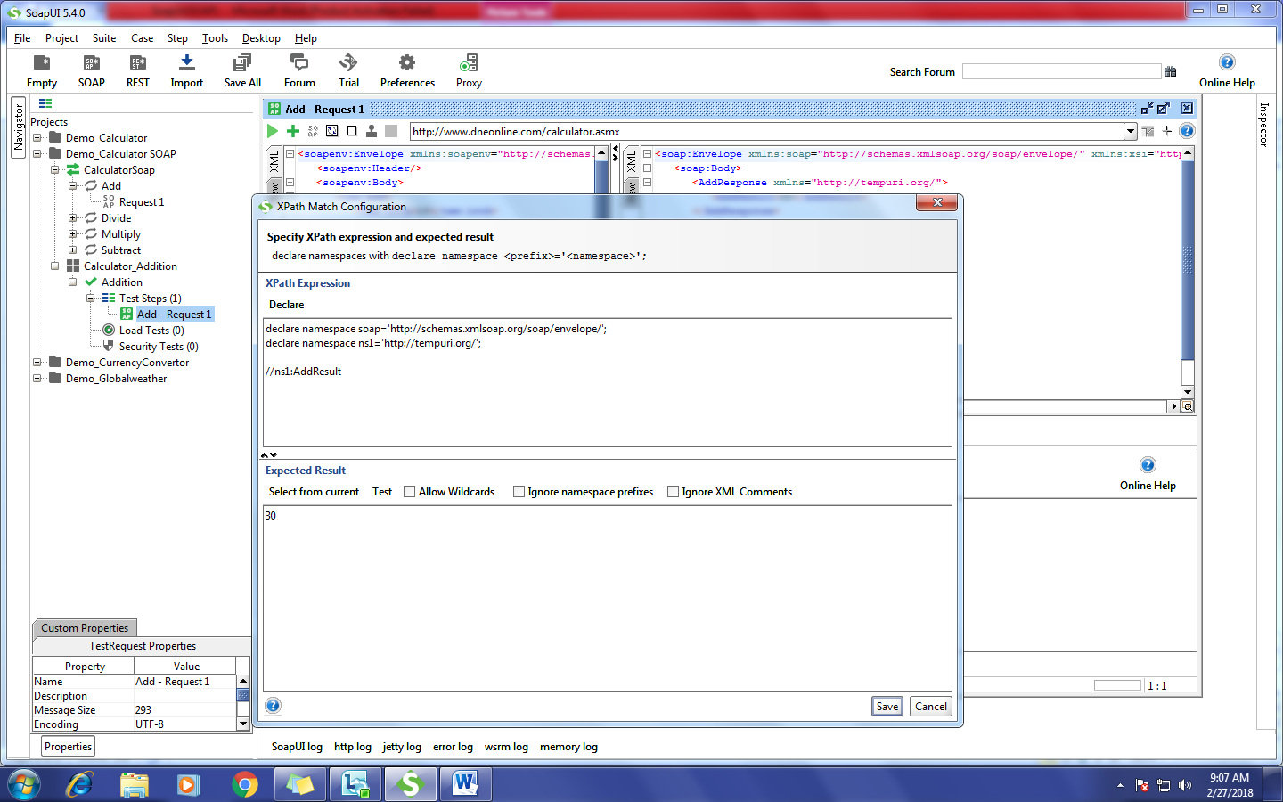

* Click On run verify the Response.

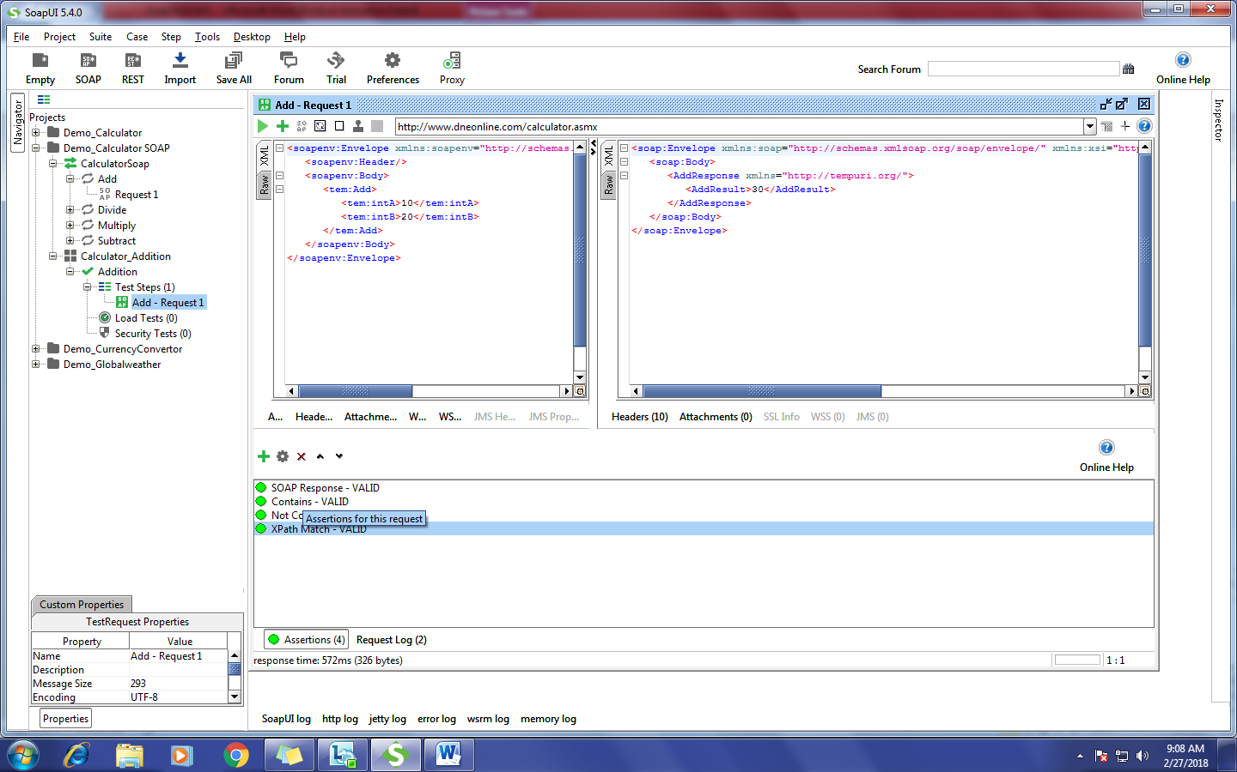

**GET DATA:**

We can get the data in 5 ways in SoapUI,

* Global
* Project
* TestSuite
* TestCase
* TestStep

**Global:**

Syntax: ${Property Name}

* Go to File
* Click on Preferences
* Go to Global Properties
* Add the Property Values

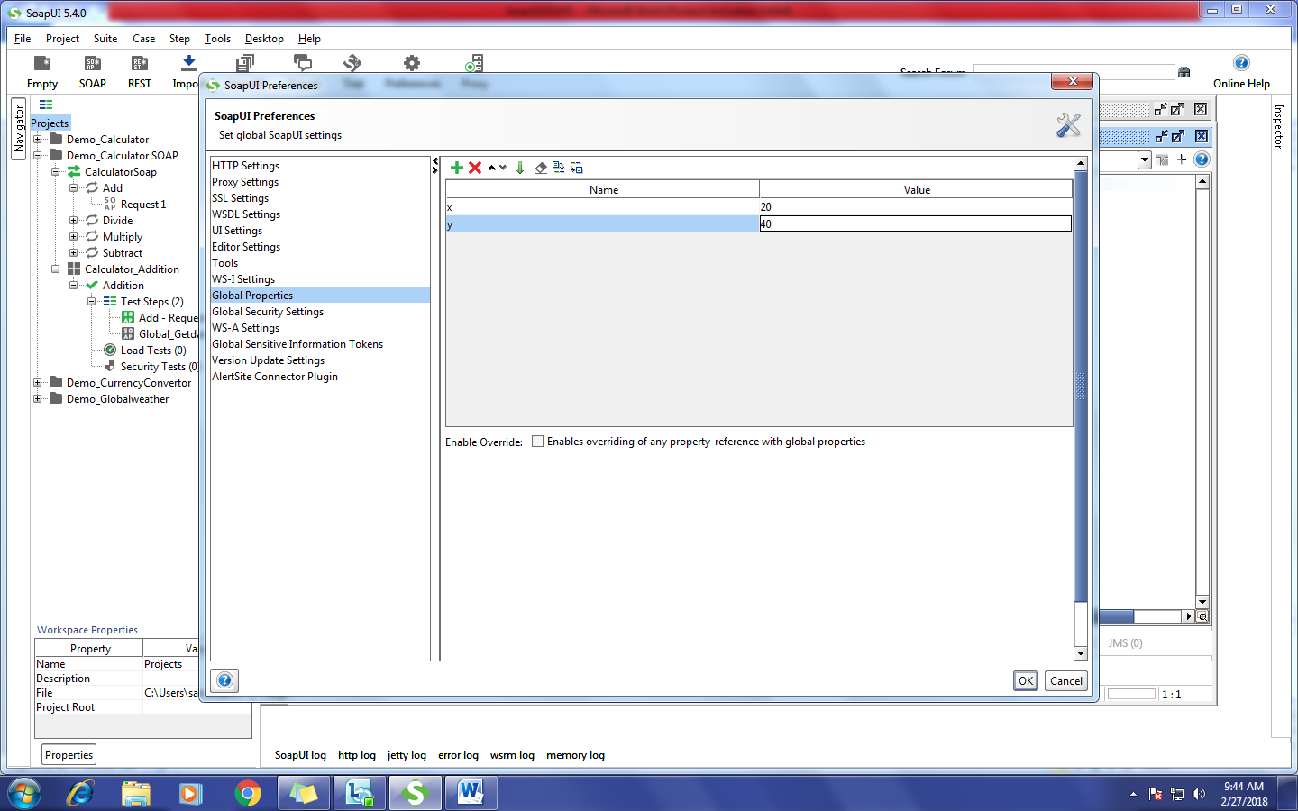

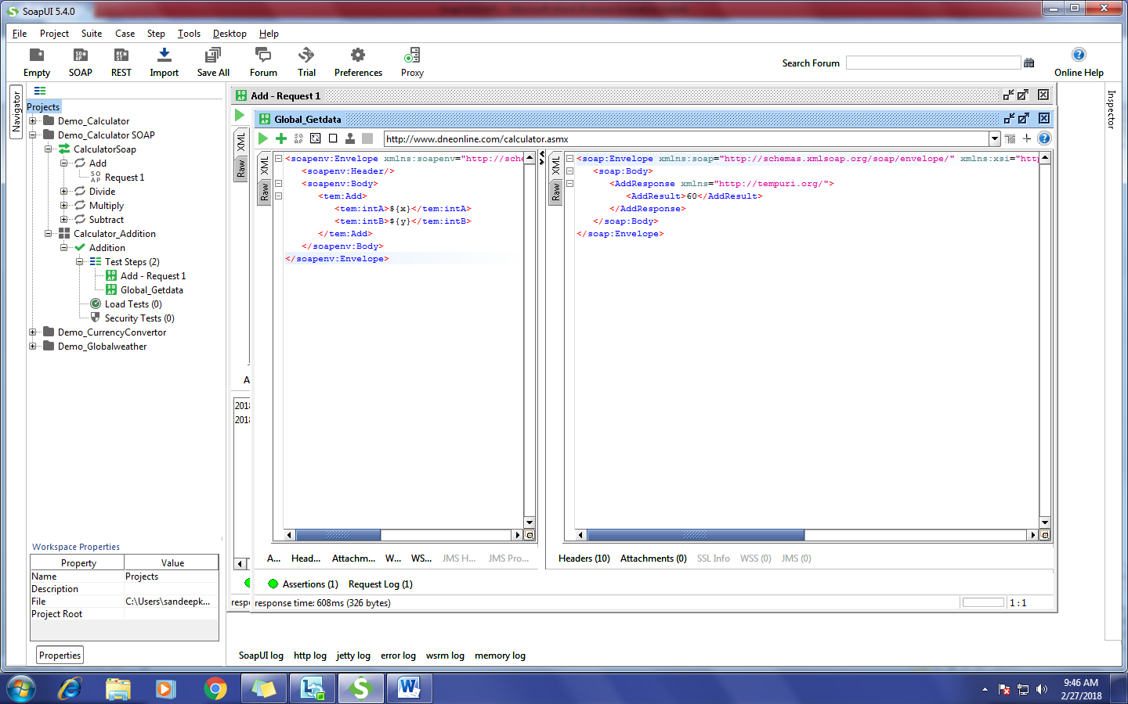

**Project:**

Syntax: ${#Project#PropertyName}

* Select the ‘Project’ and go to Custom Properties in the bottom.
* Add the Property Values.

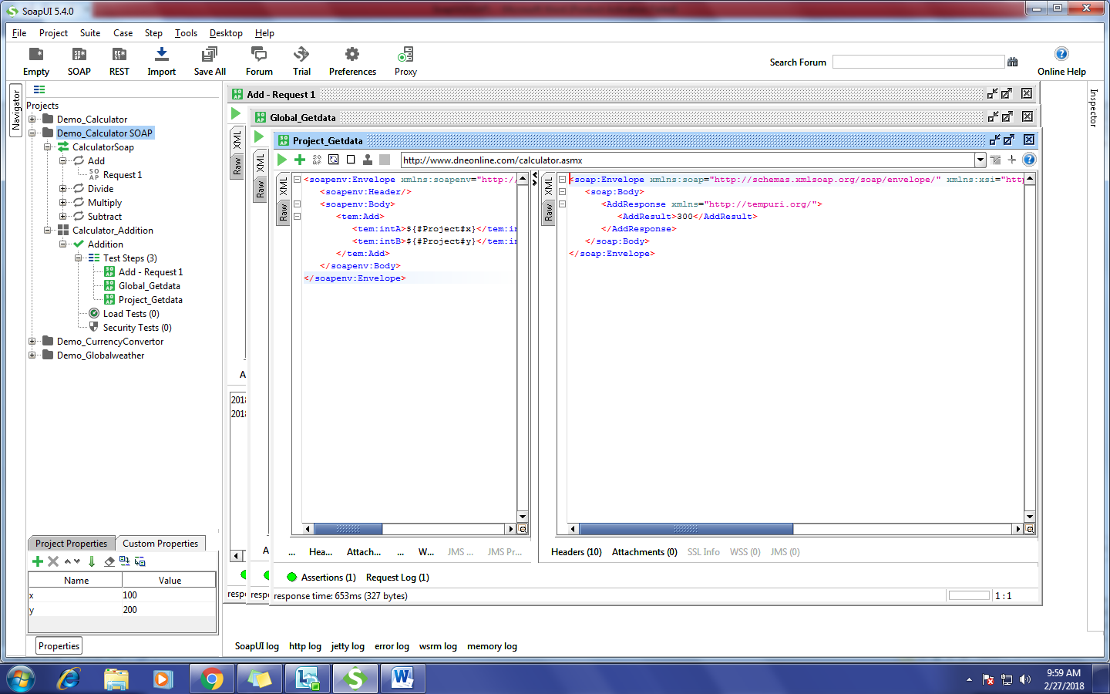

**TestSuite:**

Syntax: ${#TestSuite# PropertyName}

* Select the ‘TestSuit’ and go to Custom Properties in the bottom.
* Add the Property Values.

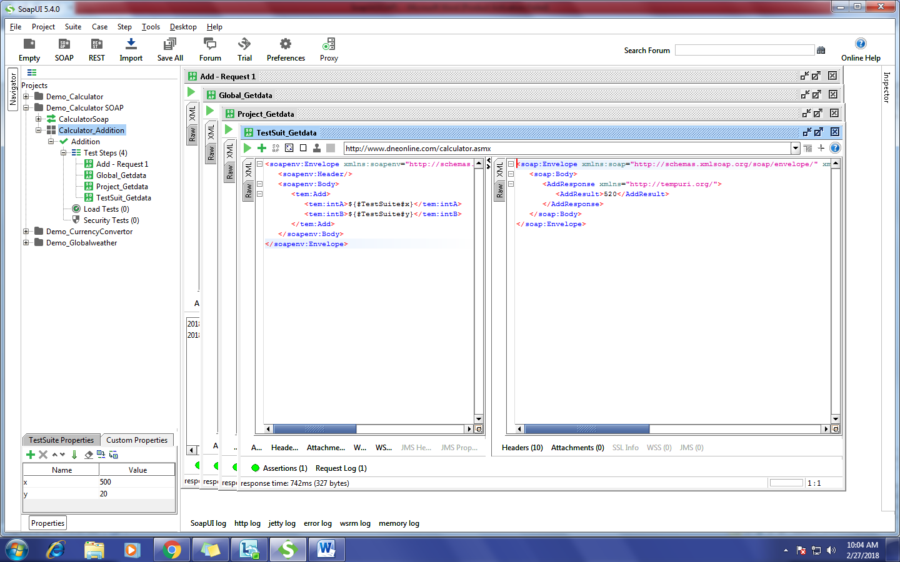

**TestCase:**

Syntax: ${# TestCase# PropertyName}

* Select the ‘TestCase’ and go to Custom Properties in the bottom.
* Add the Property Values.

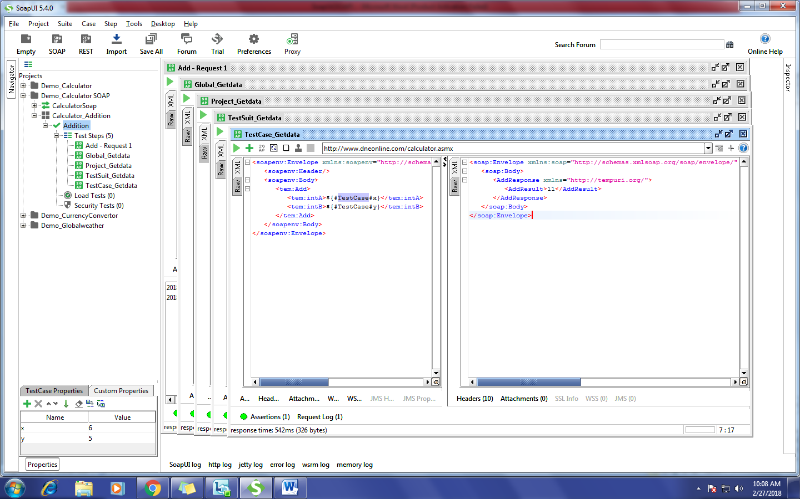

**TestStep:**

Syntax: ${Properties#PropertyName}

* Select the ‘TestStep’ and right click.
* Go to Add Step.
* Click On properties.
* Add the Property Values

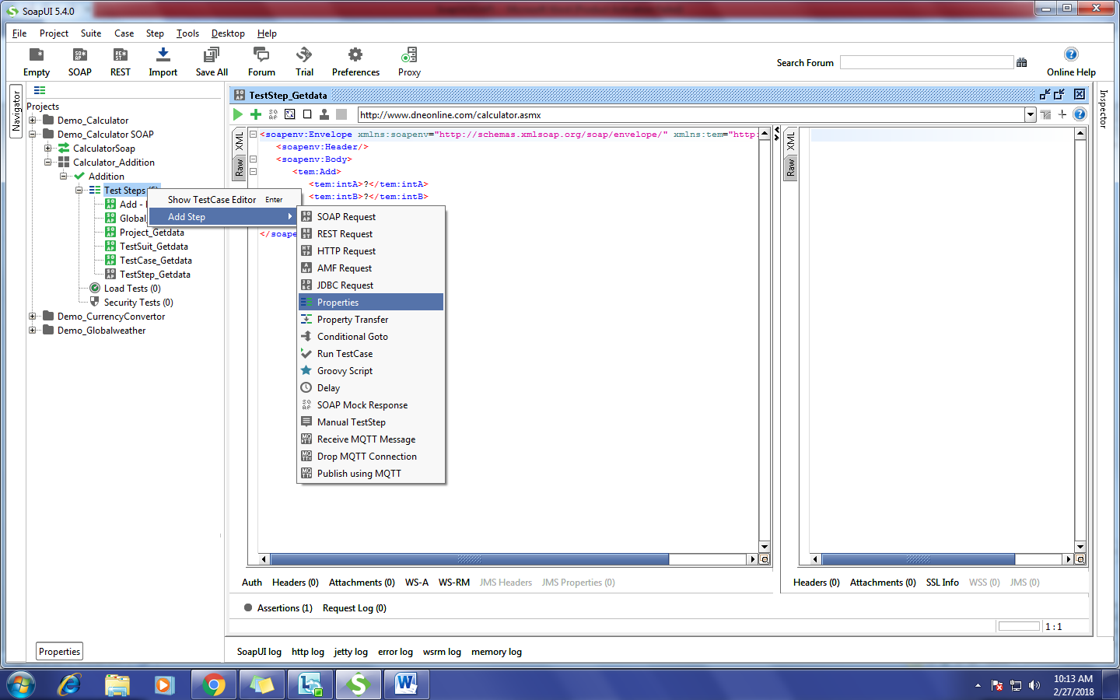

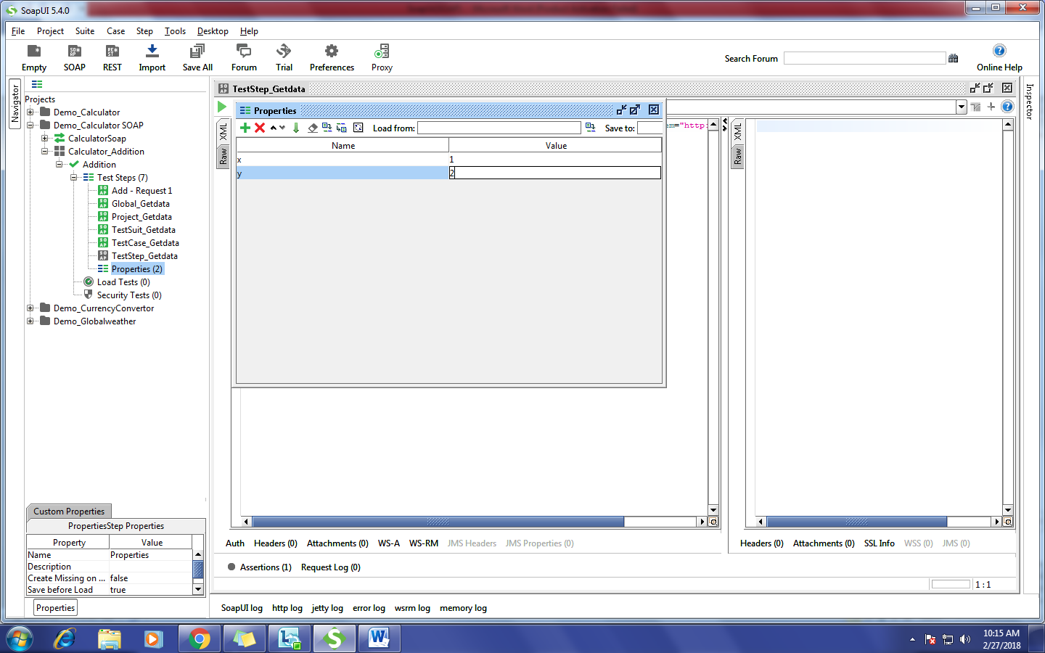

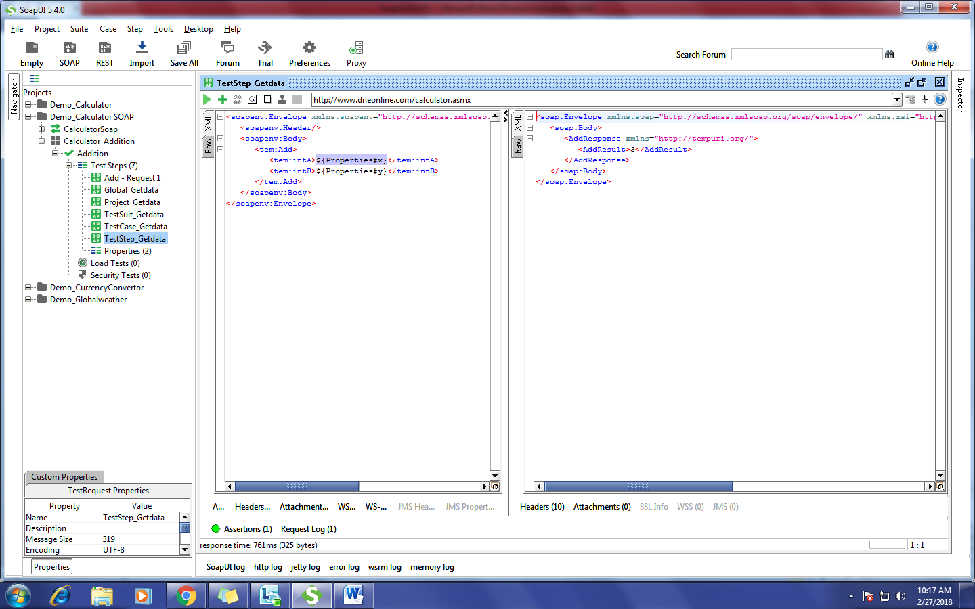

**How to Add Delay:**

* Select the ‘TestStep’ and right click.
* Go to Add Step.
* Click On Delay.

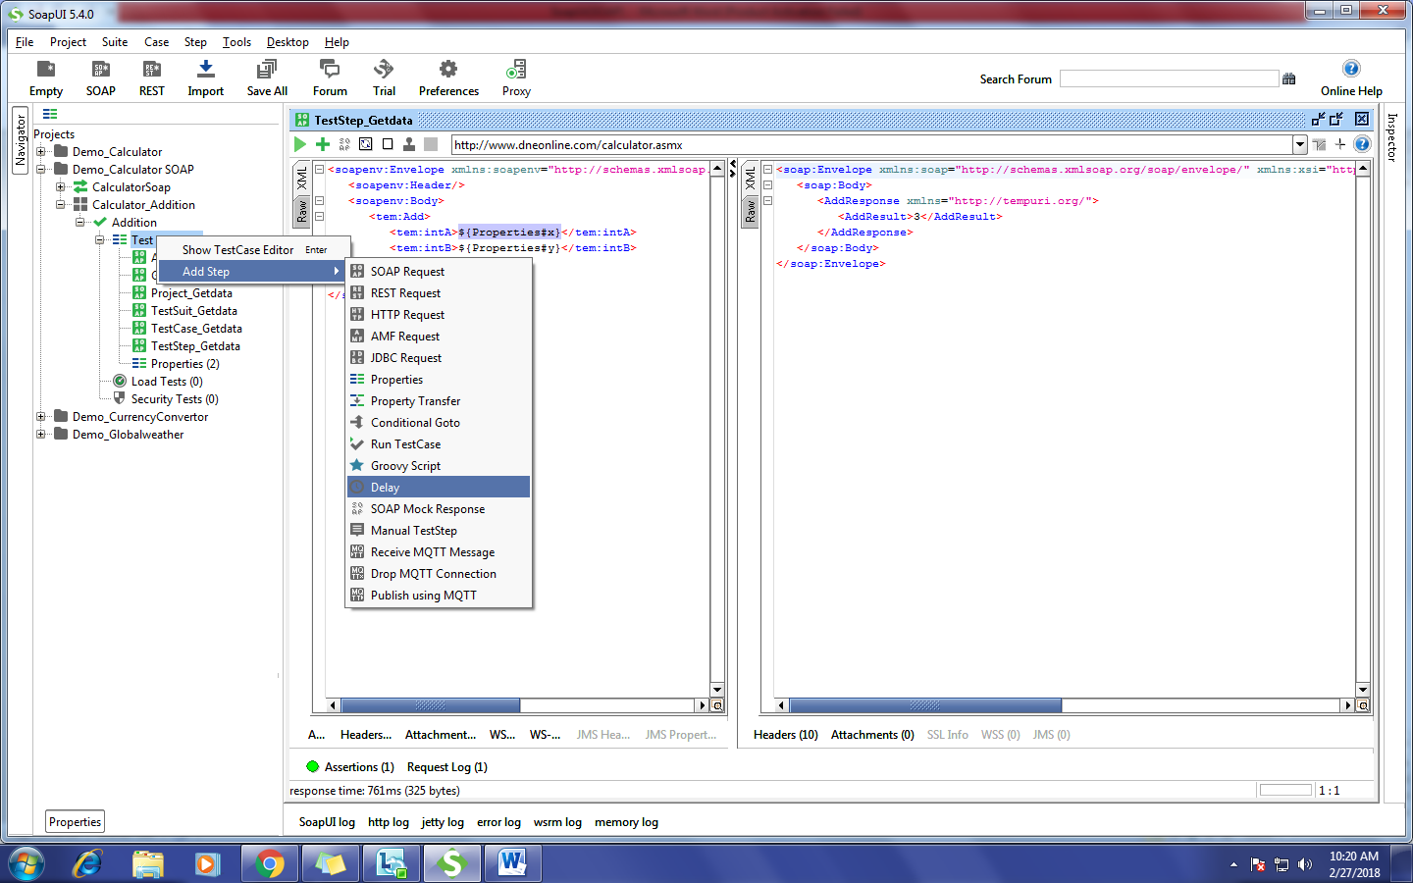

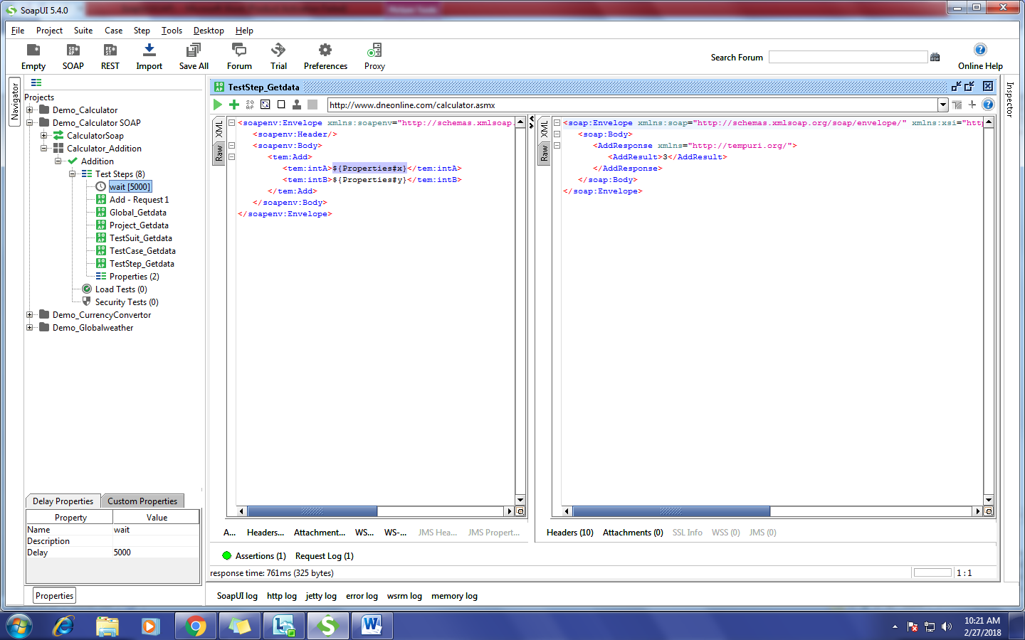

**How to Add Condition Go To:**

* Select the ‘TestStep’ and right click.
* Go to Add Step.
* Click On Conditional Go to.
* Click on Add Condition.
* Write the Condition.

Condition: If the Result is ‘30’ then go to the ‘Getdata Step’ (Step 8).

